**OUTPUT**

**Welcome Page:**

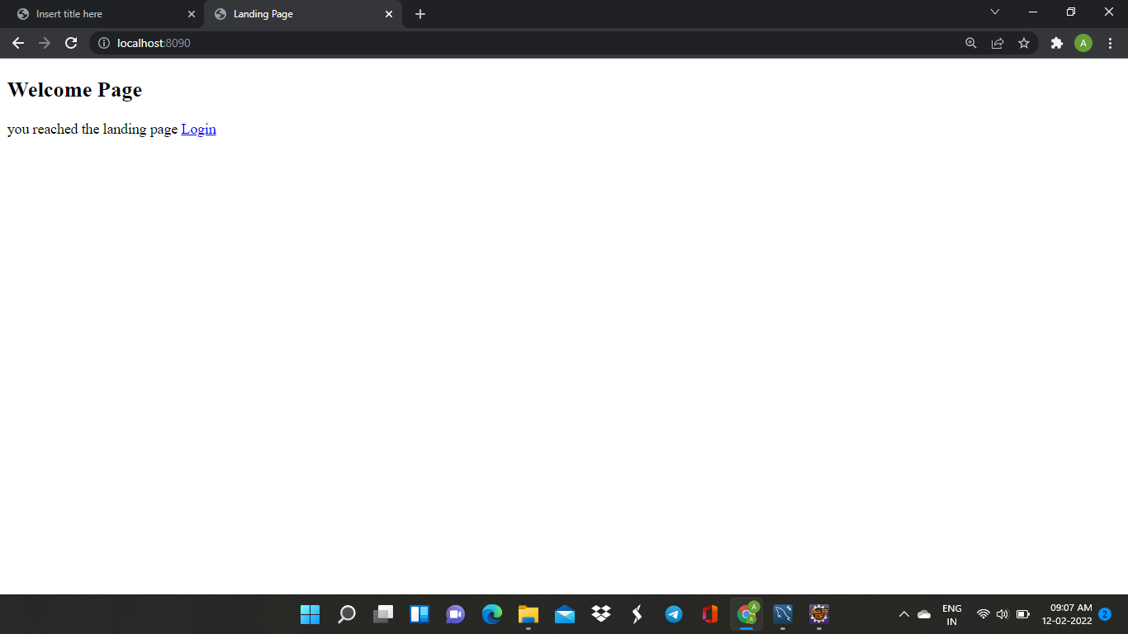

**Login Page:**(by authenticating user name and password one should login)

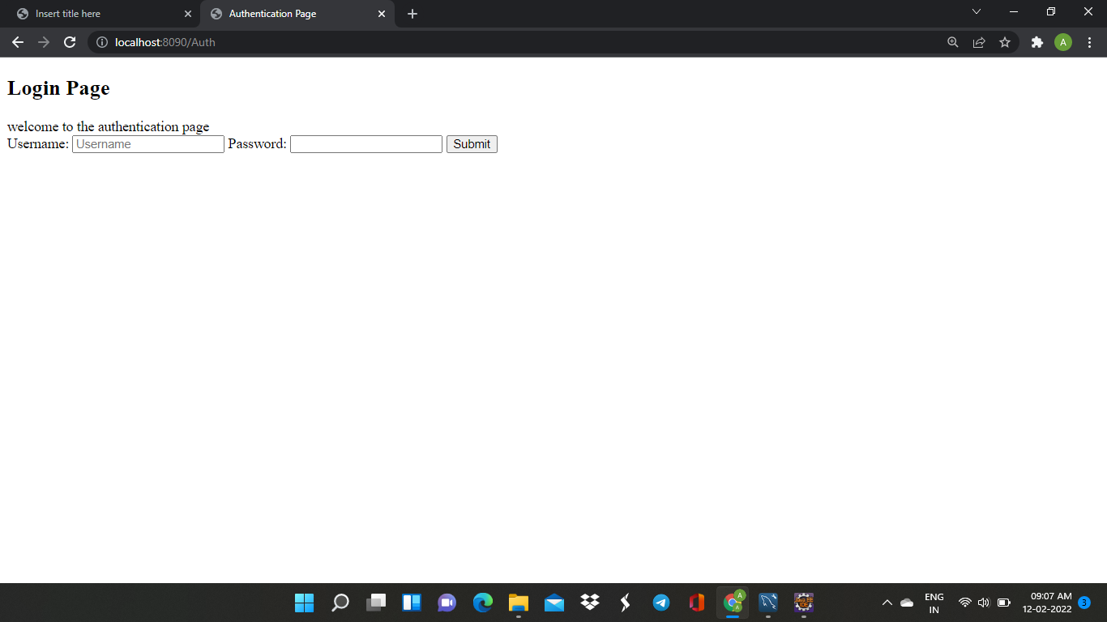

**Login Successful:**

